**DAILY ONLINE ACTIVITIES SUMMARY**

|  |  |  |  |  |  |  |  |  |
| --- | --- | --- | --- | --- | --- | --- | --- | --- |
| **Date:** | **24 June 2020** | | | | | **Name:** | **K. ISHA HEGDE** | |
| **Sem & Sec** | **4th sem, 2nd year** | | | | | **USN:** | **4al18cs031** | |
| **Online Test Summary** | | | | | | | | |
| **Subject** | | **------** | | | | | | |
| **Max. Marks** | | **----** | | **Score** | | | **---** | |
| **Certification Course Summary** | | | | | | | | |
| **Course** | **INTRODUCTION TO DIGITAL MARKETING** | | | | | | | |
| **Certificate Provider** | | | **Google garage** | | **Duration** | | | **4.5 hours** |
| **Coding Challenges** | | | | | | | | |
| **Problem Statement:2 program** | | | | | | | | |
| **Status: Executed** | | | | | | | | |
| **Uploaded the report in Github** | | | | | **Yes** | | | |
| **If yes Repository name** | | | | | **<https://github.com/iishaii/locked-down_coding>** | | | |
| **Uploaded the report in slack** | | | | | **Yes** | | | |

#### *Certification Course Summary:*

#### Today I continued with INTRODUCTION TO DIGITAL MARKETING from google garage which is of 40 hrs. After the completion of course, certificate will be provided.



***Coding Challenges:***

Today I solved 2 coding challenge,

One is given by college and another from geeksforgeeks.

1. **Write a C++ Program to Sort a stack using a temporary stack**

1)Create a temporary stack say tmpStack.

2)While input stack is NOT empty do this:  
• Pop an element from input stack call it temp  
• while temporary stack is NOT empty and top of temporary stack is greater than temp,  
pop from temporary stack and push it to the input stack  
• push temp in temporary stack

3)The sorted numbers are in tmpStack

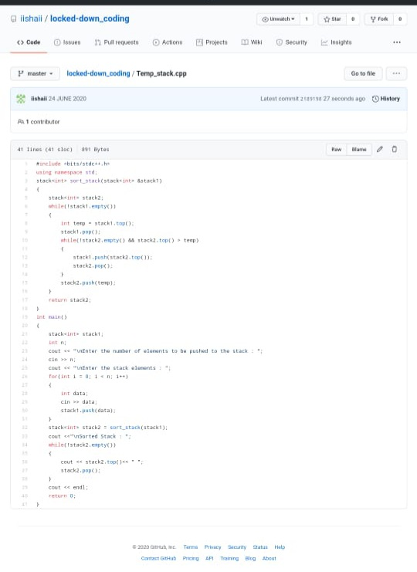

**2.** **Given the marks of all students, calculate the median.**

**I tried to solve in python.**

***Input:***

**The first line of input takes the number of test cases, T. For each test case there will be two lines. The first line contains an integer N denoting the number of students, and second line contains N space separated integers which denotes the marks of N students.**

***Output:***

**Print the floor value of the median for each test case on a new line.**

***Constraints:***

**1 <= T <= 100**

**1 <= N <= 100**

**1 <= Marks <= 100**

***Example:***

***Input:***

**3**

**4**

**56 67 30 79**

**4**

**78 89 67 76**

**5**

**90 100 78 89 67**

***Output:***

**61**

**77**

**89**

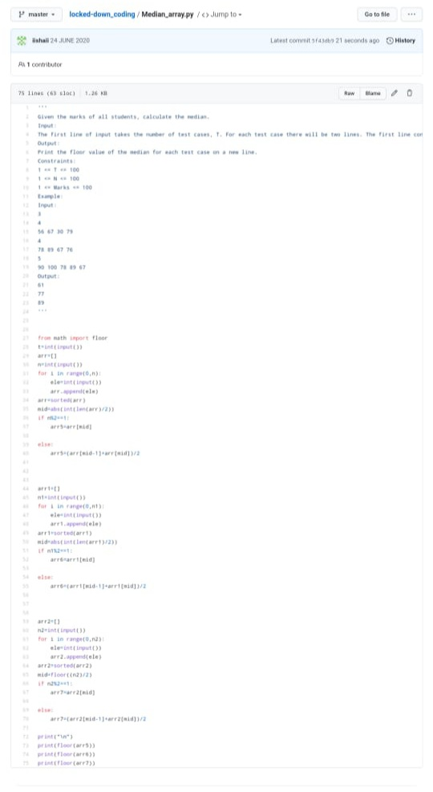

***Extra Activity:***

Today I attended Online training on C, General talk Introduction, Data types, Input and Outputs, Operators Quiz which is from 2:30-4:00 pm and we also had a quiz.

